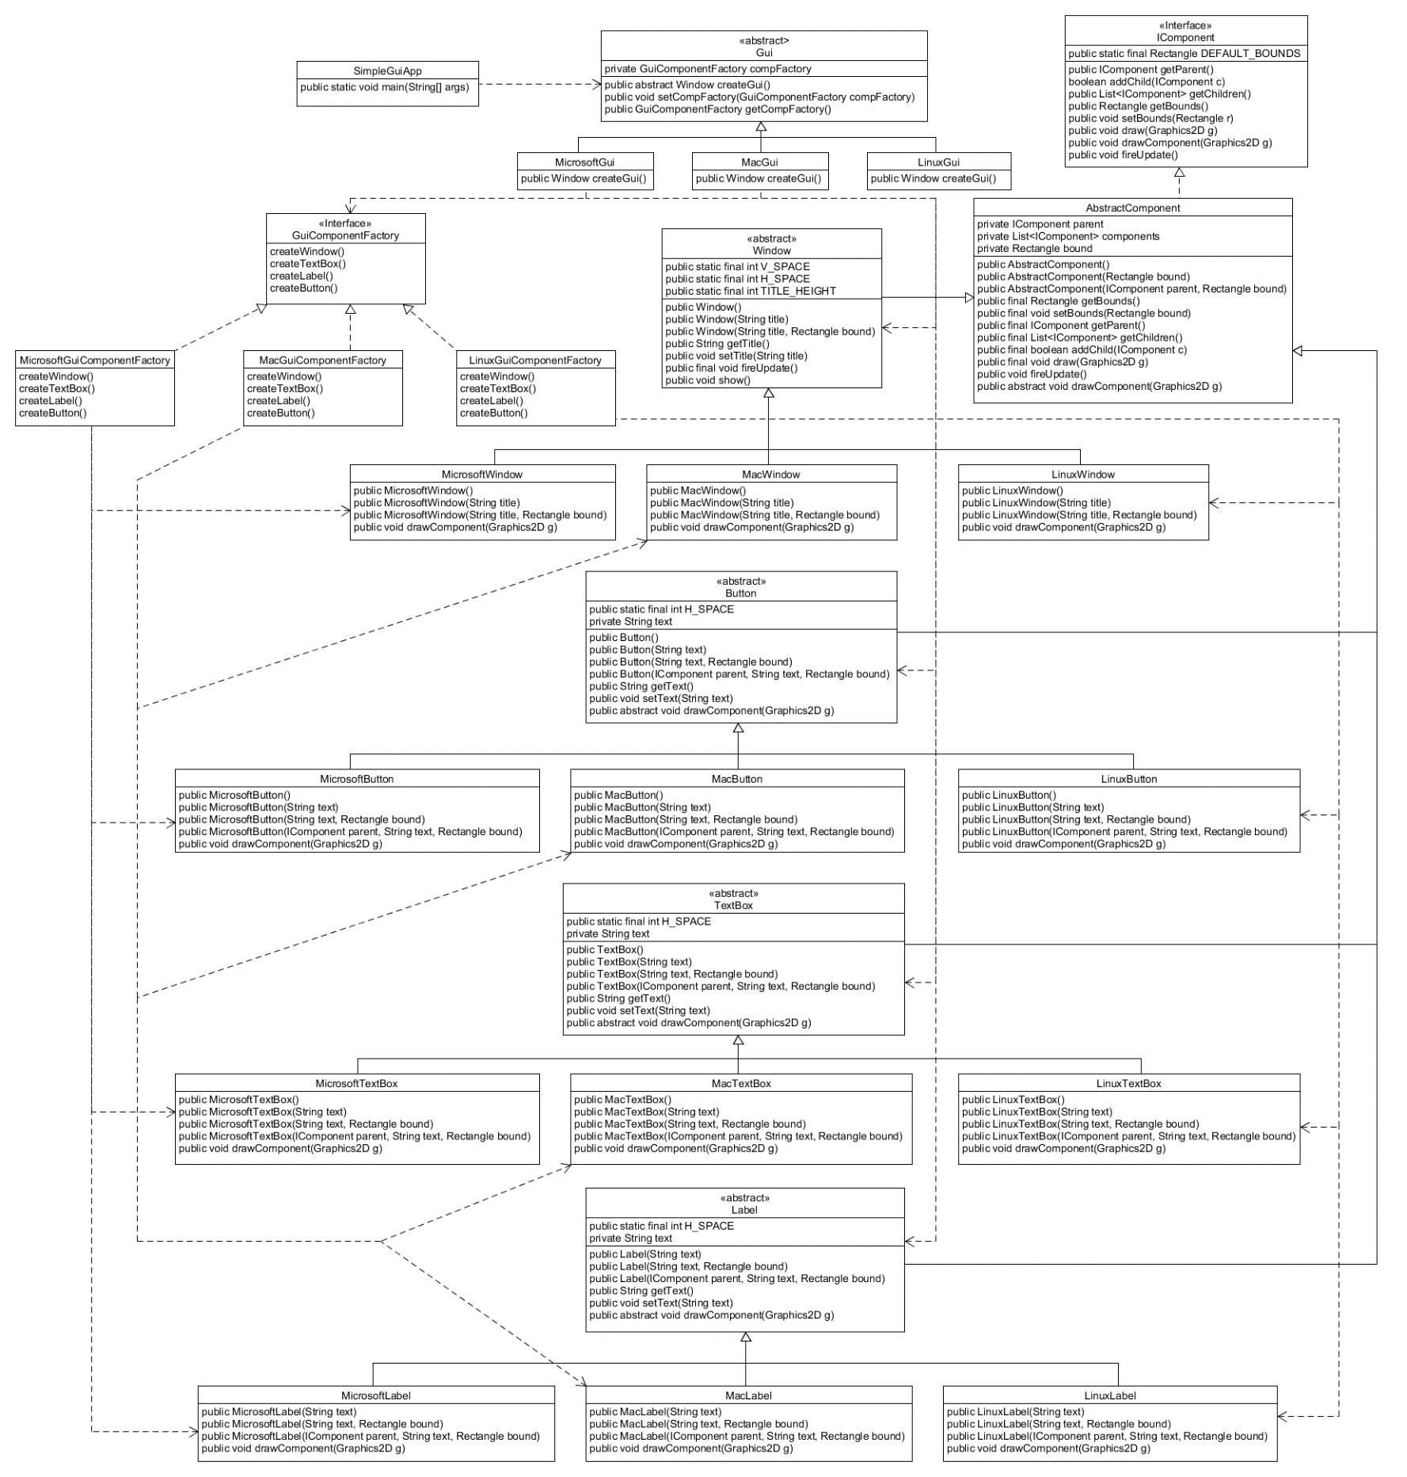1.

The SimpleGuiApp implements one of the three concrete Gui classes: MicrosoftGui, MacGui, or LinuxGui. The concrete Gui class has a createGui() method which sets the class’s GuiComponentFactory to its respective component factory (Microsoft, Mac, or Linux). After setting the component factory, one of the three Guis is created depending on the operating system. The Gui consist of a Window with a Button, TextBox, and Label. Each Gui element is an abstract class that extends AbstractComponent. The concrete implementations of the Gui elements extend the abstractions with the only major change being the drawComponent(Graphics2D g) method. Each Gui element is drawn differently so every implementation requires a different drawing algorithm.

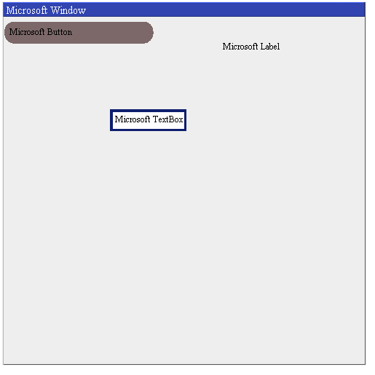3. Integration Testing

